**Page 1**

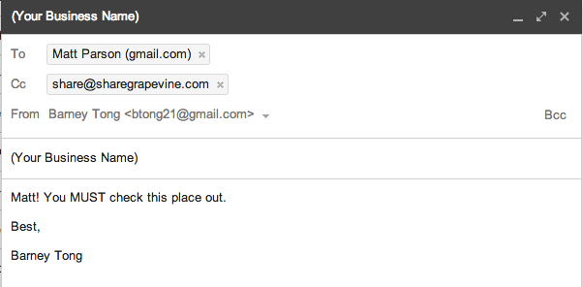

**Page 2**

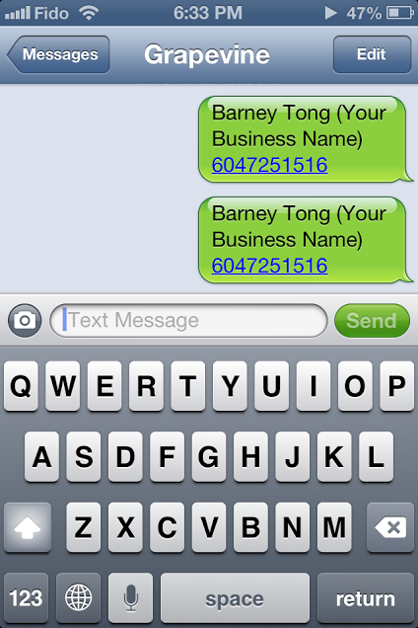(edit one of them away, and hide the text box, only showing the empty typing field and send)

**Page 3**

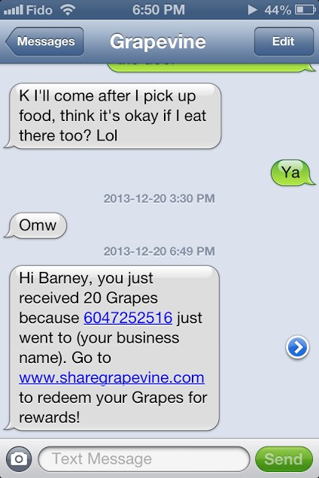

(take out previous text)

**Page 4 (Receiving a Grapevine email on gmail, please mimic as closely as possible)**

Email is

From: [share@sharegrapevine.com](mailto:share@sharegrapevine.com)

To: Barney Tong <btong21@gmail.com>

Subject: You got Grapes!

(Grapevine logo)

So you just received 20 Grapes because [parsonmatthew@gmail.com](mailto:parsonmatthew@gmail.com) just went to (your business name). Go to [www.sharegrapevine.com](http://www.sharegrapevine.com) to redeem your Grapes for rewards!

- Team Grapevine

**Page 5 (Metrics & Analytics, this would be a part of what the business sees when they log-in)**

**Page 6**